Name(s):_________________________________________________

What is the Effect of Exercise on Heart Rate?
Objectives
- Develop a hypothesis about the effects of exercise on heart rate
- Compare heart rates of individuals at different activity levels
- Determine the heart's recovery time
Safety considerations: If you have any medical conditions that may prohibit you from physical activity, abstain from the activtity and gather data from your group.
Experimental Questions: How does exercise affect heart rate? Does the type or intensity of the exercise change the results? How long does it take for the heart to return to normal?

Step 1: Design the Experiment
As a group, develop a plan to answer the experimental questions. There are many ways you can gather data, and activities that can be performed. As a group, you must consider the following and have your plan approved by your instructor before proceeding to the data gathering phase.
1) How many research subjects will you use?

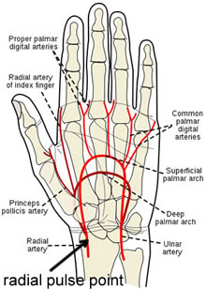
2) How will you measure heart rate?

3) What kind of exercises will your subject(s) do? How many?

4) How will you record your data?

5) How will you measure recovery time?

Step 2: Data Collection
In the space below, record your data in an organized way using tables, charts, or graphs. Your data should have all appropriate labels and units so that any person reading the data would be able to understand it. You may attach another page.

Step 3: Analysis
1. Using your data, answer the experimental questions, using complete and coherent sentences.

2. Do you think the data is reliable? Why or why not?

3. Feedback mechanisms maintain a living system’s internal conditions, allowing it to remain alive and functional even as external conditions change. How can feedback mechanisms explain the changes you observed in this activity? How do these mechanisms help an organism maintain HOMEOSTASIS? (Think carefully on this one.)

4. Suggest ways that the experiment could be improved. How could additional data could be gathered to gain more evidence for your conclusions.

